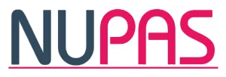

National Unplanned Pregnancy Advisory Service

Safeguarding Adults and Children Annual Report
April 2025 – March 2026

Karen Miller, Interim Executive Lead for Safeguarding

May 2026

Contents
1 | Introduction | 3
2 | Accountability | 4
3 | Governance | 5
4 | Assurance Framework | 6
5 | Policy & Guidance | 10
6 | Safeguarding Training & Supervision | 11
7 | Strategic Oversight & Leadership | 13
8 | Safeguarding Standards & Compliance Monitoring | 13
9 | Incident Reporting | 14
10 | Looking Ahead 2025/2026: Safeguarding Objectives and Strategic Developments | 14

- Introduction

NUPAS is committed to providing safe, person-centred, and holistic abortion care to everyone who accesses our services. We strive to deliver compassionate, non-judgemental care, with a strong emphasis on safeguarding, promoting wellbeing, and supporting individuals who may be experiencing vulnerability, disadvantage, or abuse.
Safeguarding remains a cornerstone of our clinical governance framework and is integral to the delivery of safe, compassionate, and equitable care. At NUPAS, we recognise that safeguarding extends beyond protecting people from harm; it also involves promoting their rights, autonomy, dignity, and wellbeing. This report reflects our continued commitment to fostering a culture in which safeguarding is everyone's responsibility and where people feel safe, respected, and supported throughout their care journey.
Over the past year, we have continued to strengthen our safeguarding arrangements through enhanced staff training, improved reporting and assurance processes, and closer collaboration with Local Safeguarding Partnerships and Integrated Care Boards (ICBs). We have also taken significant steps to ensure our services remain accessible and inclusive for all. This includes the provision of professional interpreting services, British Sign Language (BSL) support, and translated patient information to enable informed decision-making and equitable access to care.
As the complexity of safeguarding concerns continues to increase, we remain committed to supporting our staff to respond with professionalism, resilience, and compassion. Many people accessing abortion care disclose experiences of domestic abuse, sexual violence, coercion, mental ill-health, exploitation, or other forms of adversity. Ensuring that our workforce is equipped to recognise and respond appropriately to these concerns is fundamental to delivering safe and effective care.

All safeguarding activity across the organisation is underpinned by the NUPAS values and our commitment to providing high-quality, person-centred care.
This annual report provides an overview of safeguarding activity undertaken during the reporting period. It highlights the work carried out across the organisation and demonstrates how NUPAS discharges its statutory safeguarding responsibilities under Section 11 of the Children Act 2004, the Care Act 2014, and relevant national guidance, including Working Together to Safeguard Children (2026).
National data continue to demonstrate sustained demand for abortion care services across England and Wales. While final abortion statistics have not been published for recent years, previous Department of Health and Social Care data indicate that abortion rates remain at historically high levels. The factors influencing reproductive choices are complex and multifaceted, including socioeconomic circumstances, barriers to accessing contraception, relationship factors, health needs, and personal circumstances.
At the same time, many individuals continue to experience significant adversity, abuse, and inequality within their homes and communities. National data indicates that:
• Women and girls continue to experience disproportionately high rates of mental health difficulties.
• Domestic abuse, sexual violence, stalking, and coercive and controlling behaviour remain widespread.
• Reports of rape and serious sexual offences continue to present significant challenges for individuals, services, and wider society.
As an organisation, we recognise the profound impact that abuse, trauma, poor mental health, and social disadvantage can have on people's lives and healthcare experiences. The prevalence of domestic abuse, sexual violence, exploitation, and mental health needs reinforces the importance of embedding safeguarding throughout every aspect of our model of care and at every stage of the patient journey.
NUPAS is committed to ensuring that safeguarding is not simply a statutory requirement or organisational policy, but a lived reality that informs every interaction, decision, and aspect of service delivery. Through continuous learning, partnership working, and a commitment to person-centred care, we will continue to strengthen our safeguarding practice and promote the safety, wellbeing, and rights of all those who access our services.

All safeguarding work across the organisation is underpinned by NUPAS values:
- Our patients are important to us, we respect their right to choose and support them all the way.
- We are transparent in all that we do and communicate openly and honestly.
- We work as a team with a common goal: to provide the best possible care.
- We are caring and passionate about what we do.
- We value and support our staff.

Accountability

This report fulfils the requirements of the Section 11 Audit and provides a comprehensive self-assessment against the safeguarding standards set out in the Children Act (2004).

The report offers transparent insights into our safeguarding procedures and their positive impact, while also critically evaluating our safeguarding management. It highlights both our successes and areas for improvement, underpinned by robust quality assurance processes.

This year has been marked by significant quality improvements and developments, alongside challenges that have tested our safeguarding resilience.

Looking ahead to 2026/27 and beyond, NUPAS remains dedicated to delivering a flexible and responsive service that evolves to meet emerging challenges. Our safeguarding approach reflects a mature, confident, and competent workforce, one that is well-led, agile, and person-centred. We will continue to strengthen our practices, support systems, and partnerships to ensure the safety and dignity of every individual in our care.

NUPAS are very committed to effectively delivering our safeguarding responsibilities as a partner in the healthcare system and will continue to evolve this next year in a new Safeguarding Strategy evidencing organisational maturity year on year.

Governance

At NUPAS, safeguarding is underpinned by a robust governance framework that integrates seamlessly across all levels of the organization, from frontline teams to executive leadership. This structure ensures that safeguarding responsibilities are strategically embedded and consistently evidenced throughout our operations.

Our organisational design supports the fulfilment of statutory and regulatory obligations in alignment with NHS England’s Safeguarding and Accountability Framework (2022). This includes appointing Designated Leads for the Mental Capacity Act, and the PREVENT strategy.

The framework is designed to eliminate single points of failure, supported by clearly defined management and escalation pathways.

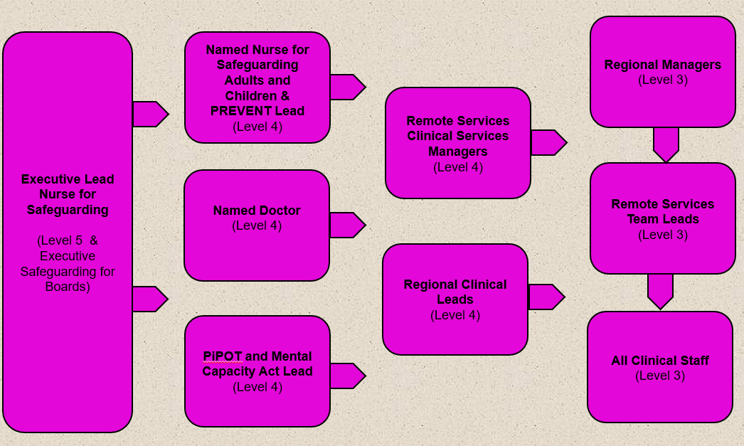

Safeguarding within NUPAS also includes:
    - Safer recruitment practices and arrangements for the management of allegations against staff who work with children or adults.
    - Safeguarding policies and procedures that support local multi-agency safeguarding procedures.
    - Effective training of all staff, commensurate with their role and responsibilities, and aligned with the Intercollegiate Documents for Safeguarding Children and Young People (2025) and Adult Safeguarding: Roles and Competencies for Health Care Staff (2018).
    - Effective clinical and safeguarding supervision arrangements for staff working with children, families, or adults at risk of abuse or neglect.
    - Effective arrangements for engaging and working in partnership with other agencies.
    - Developing and promoting a learning culture.
    - Developing an organisational culture where all staff are aware of their personal responsibilities for safeguarding and proportionate information sharing.
    - Developing a ‘trauma informed approach’ to safeguarding and the wellbeing of our staff.

NUPAS assures evidence against these requirements through completion of the SAAF where required and internally compliance is monitored quarterly via NUPAS’s Safeguarding Committee with oversight by the Clinical Governance Committee.

Assurance Framework

NUPAS has an internal assurance process. This includes a quarterly Safeguarding Committee which reports to the Safeguarding Patient Safety & Risk and Quality Oversight Committee (PSROC) which reports into the Clinical Governance Committee. The Safeguarding Committee has a performance and quality assurance role and monitors the annual work plan, safeguarding incidents, complaints and feedback, case review assurance reporting when applicable and ensures oversight of the safeguarding risk register.

Each region has a lead representative at the Safeguarding Committee to ensure that safeguarding priorities are embedded at an operational level, and this feeds back locally.

4.1 Safeguarding Risk Assessment

At NUPAS, every patient interaction is viewed as an opportunity to "make every contact count"—ensuring that safeguarding considerations are central to the care we provide. It is essential that our safeguarding risk assessments and subsequent decision-making processes are both effective and thoroughly documented.

Our clinicians are trained to gather concise and relevant information from patients, and where appropriate, liaise with external agencies and utilise national child protection information-sharing systems (CPIS).

We employ a comprehensive safeguarding risk assessment proforma that supports consistent and thorough evaluation across the following domains: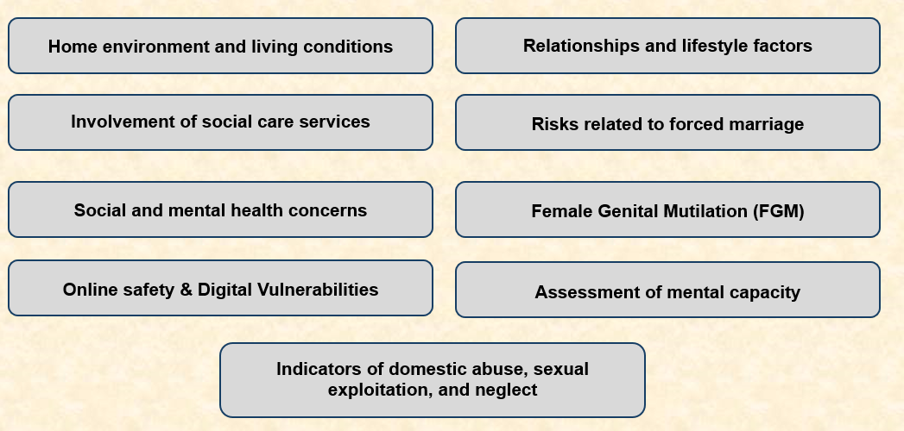

4.2 Making Safeguarding Personal

At NUPAS, our staff are fully aware of their safeguarding responsibilities. Safeguarding is not only a statutory duty, but also a core component of our commitment to making safeguarding person centred.

We strive to provide a holistic and proportionate response to individuals accessing our services, particularly those who may be vulnerable. This includes preventing harm, empowering patients to make informed decisions, and responding appropriately to disclosures. Our approach ensures that safeguarding is embedded in every aspect of care delivery, reinforcing our dedication to safety, dignity, and respect.

4.3 Safeguarding Reporting

We are a national organisation covering six regional areas plus remote services in England. Each region has local sites that support the patient pathway at place base.

Our areas cover
- The Northwest
- The Midlands
- Yorkshire and Humber
- Buckinghamshire, Oxfordshire, Berkshire & Frimley
- Greater London
- Remote Services/Telemedicine
In each region a team of Clinical Leads (trained to level 4 in safeguarding) and Deputy Clinical Leads are responsible for managing day to day safeguarding provision and assurance.

Clinical Leads are expected to work in conjunction with the Safeguarding Executive Lead and Named Professionals Safeguarding Adults and Children to ensure safeguarding meets the required standards.

This includes oversight and management of:
- Safeguarding audits and outcomes
- Supervision compliance
- Learning reviews
- Risk Register
- Local Partnership Working
Over the next year NUPAS will be reviewing its safeguarding structure with Executive safeguarding leadership transferring to the Head of Nursing & Midwifery to fully embed safeguarding leadership in clinical practice.Localised safeguarding leadership has been strengthened with Clinical Leads being trained to level 4 in safeguarding and undertaking safeguarding supervision training.

4.4 Safeguarding Audit Process

Since 2022, NUPAS has implemented a structured safeguarding audit process, using regular snapshot audits to monitor compliance and identify areas for improvement.

In 2025, we are enhancing this approach to strengthen assurance and increase the depth of scrutiny across our safeguarding standards.

From October 2025, a bespoke quarterly audit cycle will be introduced, led by the Named professional was introduced. This revised model will allow for more focused and comprehensive evaluations, enabling us to better identify trends, assess performance, and drive continuous improvement in safeguarding practice.

Going forward into 2026, the safeguarding audit tool will be revised to take into account scrutiny from learning from recent safeguarding incidents and learning from national reviws.

4.5 Safeguarding Assessments and Patient Disclosures
In 2025/26, NUPAS continued to uphold its commitment to safeguarding by ensuring that every patient accessing abortion care received a safeguarding risk assessment.
Our data indicates that:
- 100% of contacts to NUPAS has a safeguarding assessment.
- Domestic abuse continues to represent the most prevalent safeguarding risk
- For young people under 16 accessing the service, previous involvement with social care was significant in 44% of cases. Missing episodes and episodes of being in foster care also increased the safeguarding risks for this cohort, emphasising the need for professional curiosity in assessments of risks in relation to ‘father of the pregnancy’

4.6 Early Identification and Safeguarding Patient Pathway
NUPAS safeguarding procedures are designed to ensure that every patient undergoes an initial risk assessment during their first telephone consultation. This early engagement allows us to identify potential safeguarding concerns at the outset of the patient journey and work collaboratively to place individuals on the most appropriate treatment pathway.

The data presented in this report provides assurance that safeguarding issues are being identified promptly, enabling timely interventions, risk mitigation, and consistent safety-netting throughout the care process. This proactive approach reflects our commitment to safeguarding as a continuous and integrated element of patient care.

Figure… shows the safeguarding disclosures made by patients by category when accessing abortion.

4.7 Disclosure Trends, Partnership Working, and Data Improvements
In 2025/26, disclosures related to Domestic Violence and Abuse and Sexual Abuse, including Child Sexual Exploitation, remained the two most frequently reported safeguarding concerns among patients accessing NUPAS services—consistent with trends observed in 2024525.

Our most frequent information-sharing partner continues to be General Practitioners (GPs), followed by Children’s Social Care and Safeguarding Midwives. Staff routinely signpost patients to appropriate support services based on individual circumstances, leveraging both national and region-specific partnerships. These include, but are not limited to:
- Women’s Aid
- Refuge
- National Centre for Domestic Violence
- Local housing services
- Female Genital Mutilation (FGM) Specialist Clinics
- Police
NUPAS identified the need to strengthen data collection around partnership referrals to better reflect the breadth and impact of our safeguarding work. In response, we implemented a Safeguarding Assurance Form within our existing quality management system. This enhancement has significantly improved our ability to capture safeguarding disclosures within electronic patient records and extract meaningful insights via live analytical dashboards.

The assurance forms are submitted directly to the Safeguarding Team every 24 hours, enabling real-time oversight of all safeguarding disclosures, particularly for patients under 18 and adults at risk. Categorisation of concerns aligns with national safeguarding policy and the Royal College of Paediatrics and Child Health (RCPCH) guidance for children and young people accessing early medical abortion services.

NUPAS is committed to improving access to national information-sharing systems for Child Protection – Information Sharing (CP-IS) and Female Genital Mutilation – Information Sharing (FGM-IS) alerts. CPIS checks are carried out for all under 18’s accessing our services and for adults where significant safeguarding concerns are disclosed (ie. Previous children removed from their care). This supports are decision making around the right to confidentiality for our patients over the need to share proportionate and necessary information with our partner agencies.

5.Policy and Guidance

NUPAS maintains appropriate safeguarding policies and procedures. In 2025 a scheduled review accompanied by a widespread consultation process of all safeguarding policies was completed. Additional review will also take place in April 2026 to account for national statutory guidance updates.

The policy review ensured alignment with updated assessment tools and was supported by a structured launch process to facilitate a smooth transition for staff. This involved additional teaching sessions, staff briefings to understand how policy translated into operational practice. Staff feedback alongside the application of learning from safeguarding incidents also guided policy and practice change.

All policies are hosted on a live portal embedded within our quality management software, allowing staff to access only the most current, approved versions.

New policies undergo rigorous consultation with subject matter experts and are subject to Equality Impact Assessments to ensure inclusivity and fairness.

Key safeguarding policies currently in place include:

- Management of Allegations Against People in Positions of Trust (PiPOT)
- Modern Slavery and Human Trafficking
- Safeguarding Adults at Risk
- Safeguarding and Management of Patients Under 18
- Safeguarding Supervision Policy
- Female Genital Mutilation Policy
- Concealed Pregnancy Policy
- Domestic Abuse Policy
- Escalation Policy

6.Safeguarding Training and Supervision

NUPAS aligns its safeguarding training and supervision requirements with the respective Department of Health Intercollegiate Documents. This ensures that all staff receive training that is nationally recognised, role-appropriate, and reflective of current safeguarding standards.

6.1 Training Compliance
Mandatory safeguarding training at NUPAS includes:
- Safeguarding Adults and Children – Levels 1 to 3
- Safeguarding Level 4 (for applicable roles)
- PREVENT – Level 3
- Mental Capacity Act Training
- Child Sexual Exploitation Awareness
- Female Genital Mutilation (FGM) Awareness
- Oliver McGowan Mandatory Training on Learning Disability and Autism

6.2 Embedding Safeguarding Competence Through Training

This structured safeguarding training programme equips NUPAS staff with the knowledge and confidence to recognise, respond to, and manage safeguarding concerns effectively. It reinforces our commitment to maintaining a skilled, informed, and responsive workforce capable of delivering safe, high-quality, and person-centred care across all service areas.

By aligning training to national standards and role-specific requirements, we ensure that safeguarding remains a core competency throughout our organisation, supporting both proactive risk identification and compassionate patient support.

Safeguarding Training Compliance (April 2026)
Training Package | Compliance Rate
Safeguarding Adults Level 1 | 100%
Safeguarding Adults Level 2 | 100%
Safeguarding Adults Level 3 | 100%
Safeguarding Children Level 1 | 100%
Safeguarding Children Level 2 | 100%
Safeguarding Children Level 3 | 100%
Safeguarding Level 4 | 100%

6.3 Safeguarding Training Enhancements and Future Priorities
In 2025, NUPAS identified the need to refresh Level 4 Safeguarding Training due to staffing changes. To address this, external training was commissioned in March 2025, with two cohorts receiving training in July 2025. Further staff were identified who could benefit from training and received training in March 2026.

The safeguarding training at level 3 has a strong focus on domestic abuse, sexual exploitation and assessment of risk. Case scenarios from NUPAS are used to enhance training. We also include the recognition of diversity, culture and inclusion, also with the use of relevant scenarios from NUPAS practice, developing the concept and understanding of unconscious bias.

6.4 Safeguarding Supervision and Professional Development

At NUPAS, safeguarding supervision is recognised as a vital component of professional development for practitioners working with children, young people, and vulnerable adults.

In line with the updated Working Together to Safeguard Children guidance (2026), we ensure that staff have access to high-quality supervision that promotes critical reflection on the impact of their decisions on patients and their families.

We acknowledge the emotional demands placed on staff working in safeguarding roles and the importance of regular peer support, knowledge exchange, and structured supervision. These elements are embedded within our trauma informed safeguarding framework to promote resilience, professional growth, and safe practice.

6.5 Safeguarding Supervision Structure

NUPAS has a structured safeguarding supervision framework in place supported by the Safeguarding Supervision Policy (2026) that outlines supervision requirements across the organisation, including the frequency and format in which it is delivered. This framework ensures that all colleagues receive supervision tailored to their role, level of responsibility, and individual needs. Individual and ad-hoc supervision sessions are also offered as required.

NUPAS safeguarding supervision takes place using a hybrid approach of virtual and face to face meetings. Supervision is designed to create meaningful learning opportunities, support reflective practice, and address the unique challenges posed by our geographically dispersed service model and remote working arrangements. By embedding supervision into our safeguarding infrastructure, NUPAS promotes consistency, professional development, and emotional resilience among staff working with vulnerable individuals.

At NUPAS, group safeguarding supervision is a structured and collaborative process that brings colleagues together to reflect on their practice in a supportive environment. This approach fosters a culture of peer learning, shared accountability, and professional growth.

Group supervision enables staff to explore complex safeguarding scenarios, share insights, and strengthen their confidence in decision-making. It also promotes emotional resilience and reinforces our commitment to continuous improvement in safeguarding across all service areas.

7.0 Strategic Oversight & Leadership

NUPAS is committed to fostering a just and fair culture that promotes accountability, learning, and continuous improvement across all areas of safeguarding practice. As a regulated healthcare provider, we operate in full compliance with Care Quality Commission (CQC) regulations, national legislation, and clinical standards of care.

Our robust governance framework ensures that safeguarding is embedded within our organisational quality systems. This enables NUPAS to consistently meet the standards expected by us, while maintaining a strong focus on patient safety and service excellence.

The Safeguarding Committee functions as a subcommittee of the Patient Safety and Risk Oversight Committee, meeting at least quarterly. These meetings provide strategic oversight of national and regional safeguarding activity, including audits, incident themes and trends, compliance metrics, and quality improvement initiatives.

Our governance processes also ensure that legal requirements and national guidance are fully integrated into operational practice. This includes leveraging partnerships with external agencies to safeguard vulnerable adults and children across all NUPAS services, reinforcing our commitment to collaborative, safe, and person-centred care.

8.0 Safeguarding Standards and Compliance Monitoring

NUPAS utilises a comprehensive organisational safeguarding standards tool aligned with the NHS England Safeguarding Adults Assurance Framework (SAAF) and relevant children's safeguarding requirements to monitor compliance with statutory safeguarding responsibilities for adults, children, and young people.

9.Incident Reporting

Embedding PSIRF Principles in Safeguarding Incident Management

NUPAS utilizes the Patient Safety Incident Response Framework (PSIRF), reinforcing our commitment to managing incidents in alignment with national patient safety principles. All incidents reported through our quality management system are now reviewed and responded to in accordance with PSIRF standards. System-based learning is in place, using a range of methodologies to understand contributory factors, system influences, and opportunities for improvement.
Our approach is guided by the following core principles:

- Compassionate engagement with individuals affected by patient safety incidents, ensuring a psychologically safe and supportive environment
- System-based learning, applying a range of methodologies to understand the root causes of incidents and drive meaningful improvement
- Proportionate and well-considered responses that reflect the nature and complexity of each incident
- Supportive oversight, focused on strengthening system functions and embedding sustainable improvements

10.Looking Ahead 2026/2027: Safeguarding Objectives and Strategic Developments

In 2026, we will continue to focus on strengthening local safeguarding partnerships at the regional level, building on our existing external collaborations, training initiatives, and engagement strategies to deliver meaningful outcomes for patients.

Progress against these objectives will be monitored through our established committee structures, providing assurance of improved engagement and measurable impact.

Internally, NUPAS is looking to review the information captured in the safeguarding assessment tool to more accurately reflect the policy changes. There is need for our safeguarding assessment to be more culturally aware and to implement a less structured more conversational approach to assessing risks, whilst still capturing key data. This is recognition that many of the questions asked in our safeguarding assessment could be very triggering for patients, and therefore there is a need to adopt a different approach.
There is a need to promote professional curiosity through structured questioning, supporting early intervention and effective risk mitigation for patients at risk of harm.

Safeguarding training and supervision will continue to build on the work of the last year. Training and supervision will continue to focus additionally on:
- Sexual exploitation and child sexual abuse risk
- Managing mental illness and suicidal ideation
- Domestic abuse and co-ercive control
- Unconscious Bias
- Identification and management of safeguarding risks, enabling staff to make timely, informed decisions. The tool promotes professional curiosity through structured questioning, supporting early intervention and effective risk mitigation for patients at risk of harm.

